**Application Insight**

Application insight is feature of azure monitor that help to monitor live application ( Url Based monitoring)

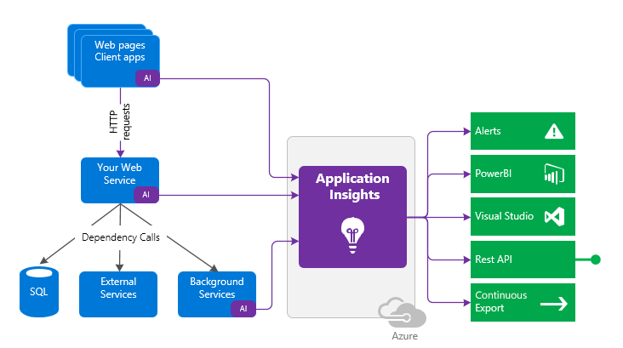

User send Request it goes to web service than database and all along with them It generate logs to application insight via that we generate some alerts and build Power BI dashboard and all

**Configuration:**

Make One webapp

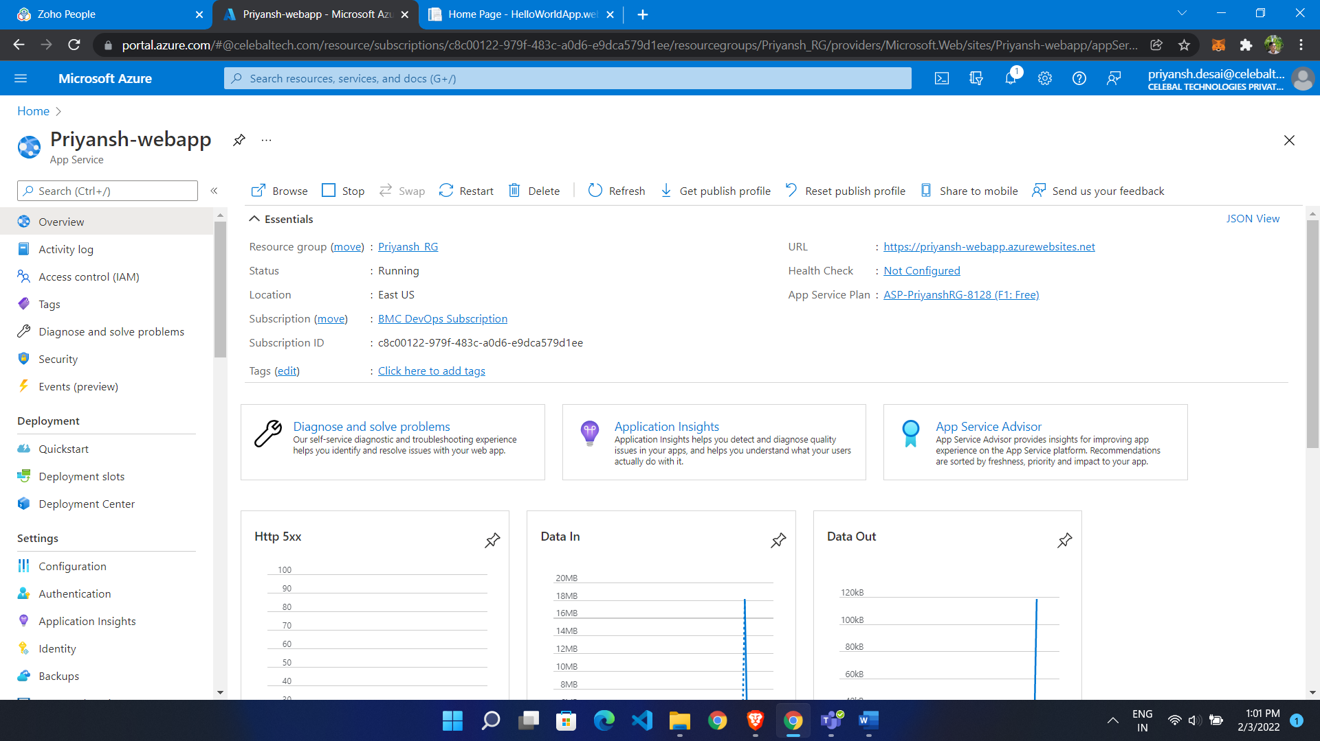

* Go to app service
* From left menu
* Choose Application insight
* Click on Enable
* Choose type of application

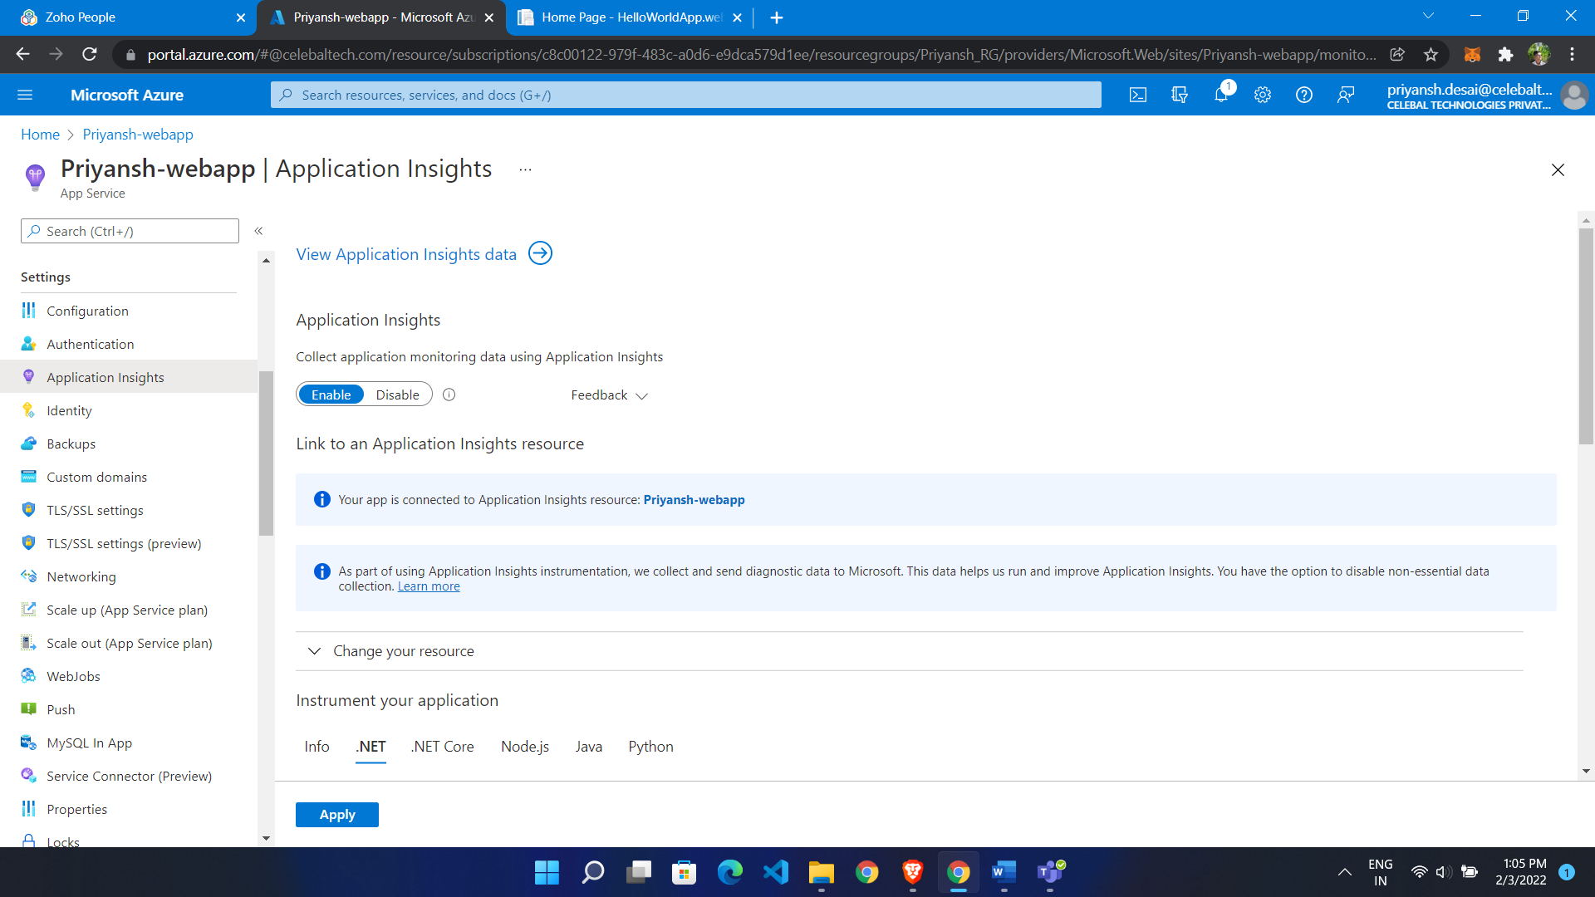

If we want to monitor on premises environment than we use instrumental key

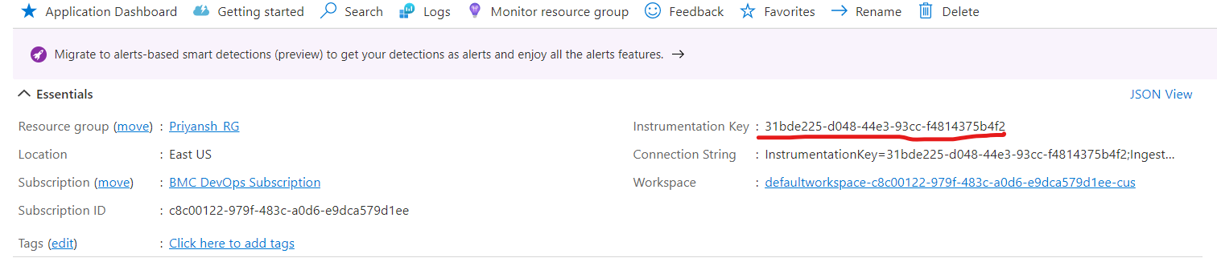

Smart Detection:

In backend it uses AI

It will detect all that automatically

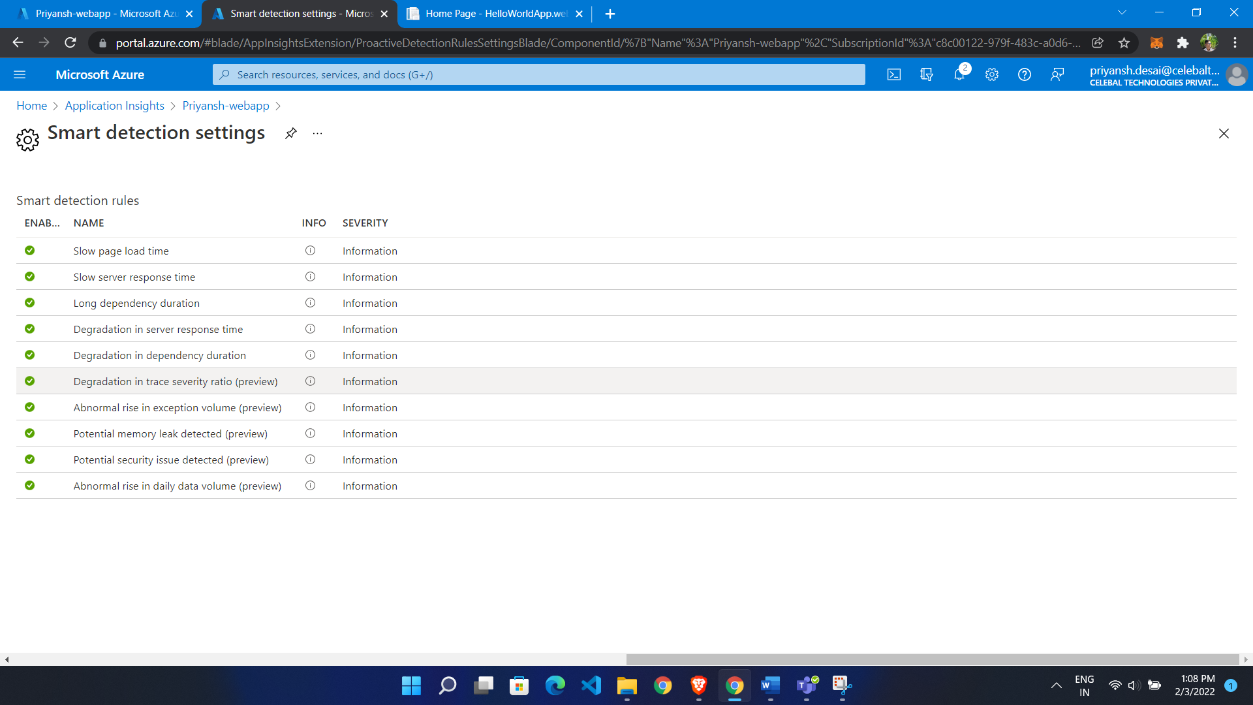

Live metrics:

It will see incoming request, overall health and all

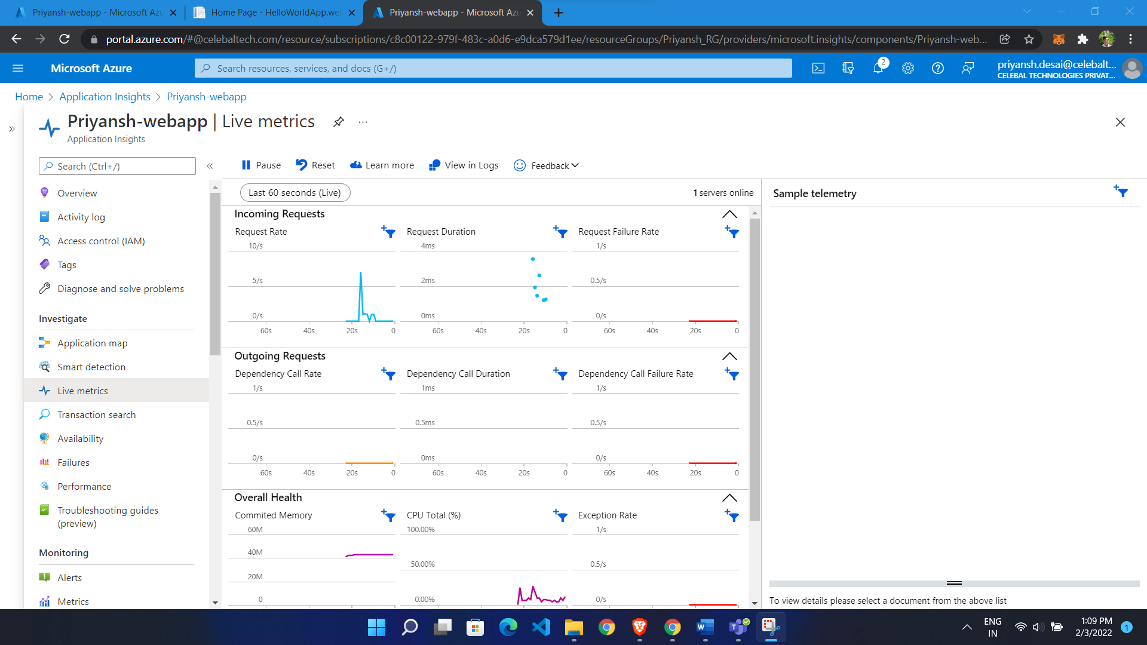

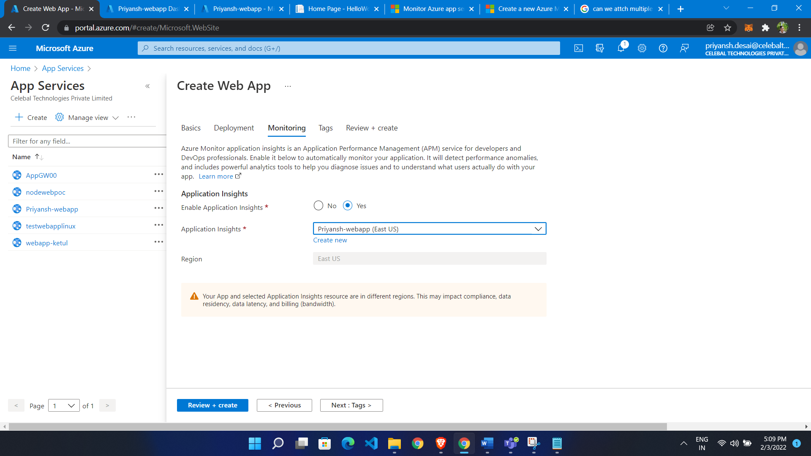

Transaction Search: in our application there is any transaction than it show us

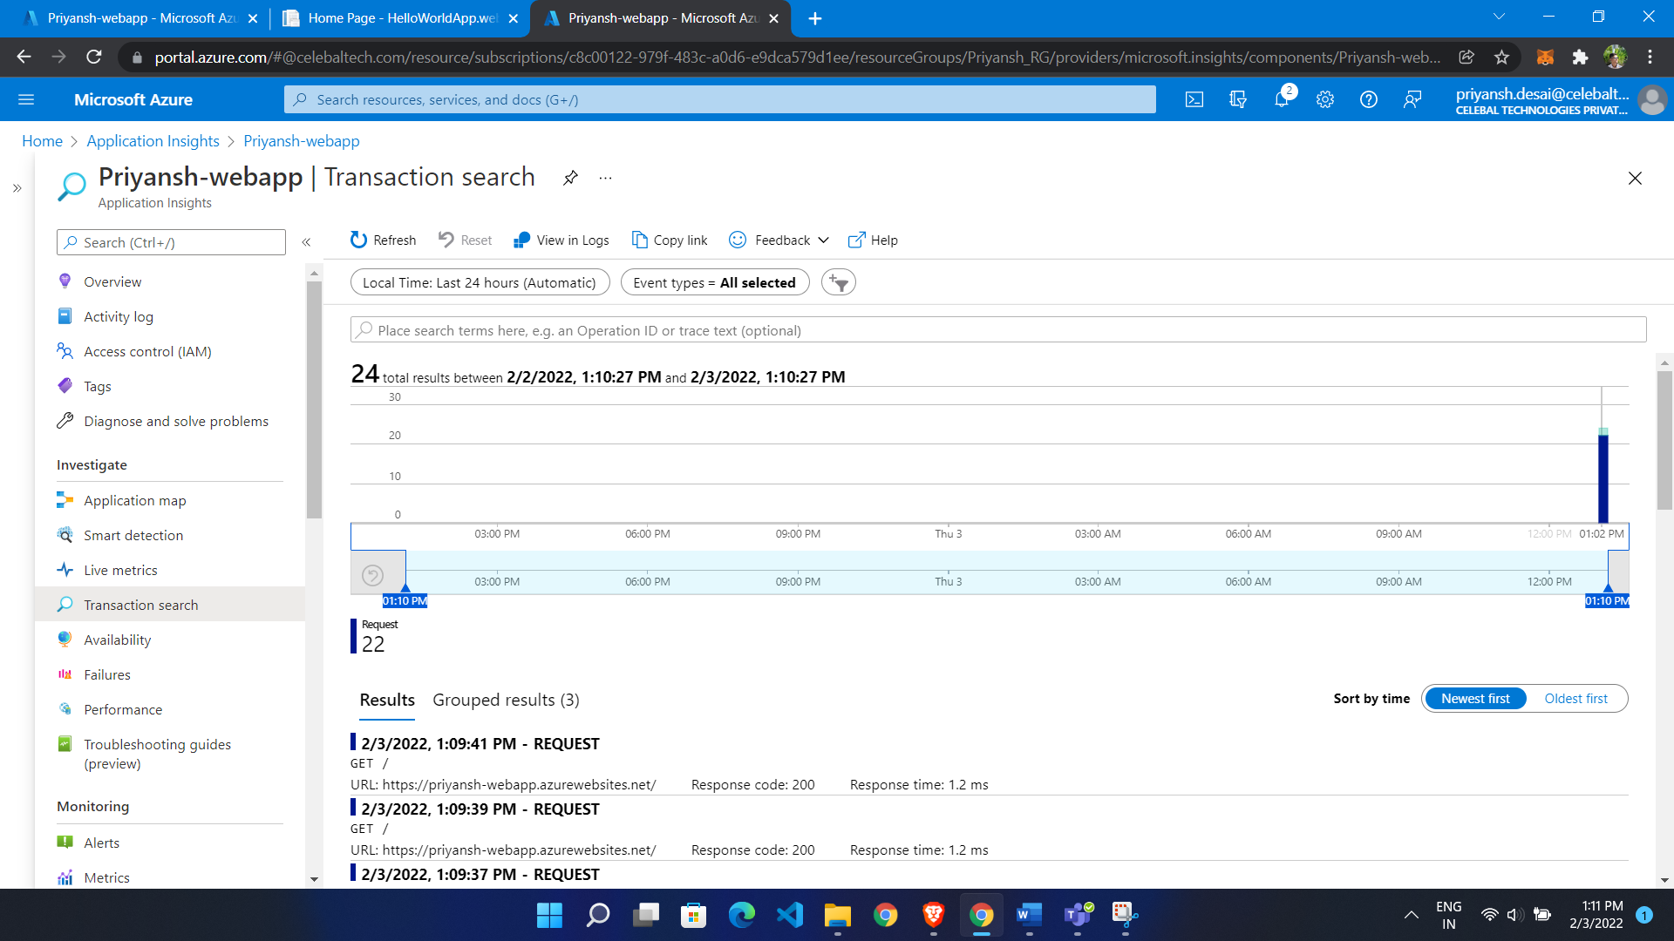

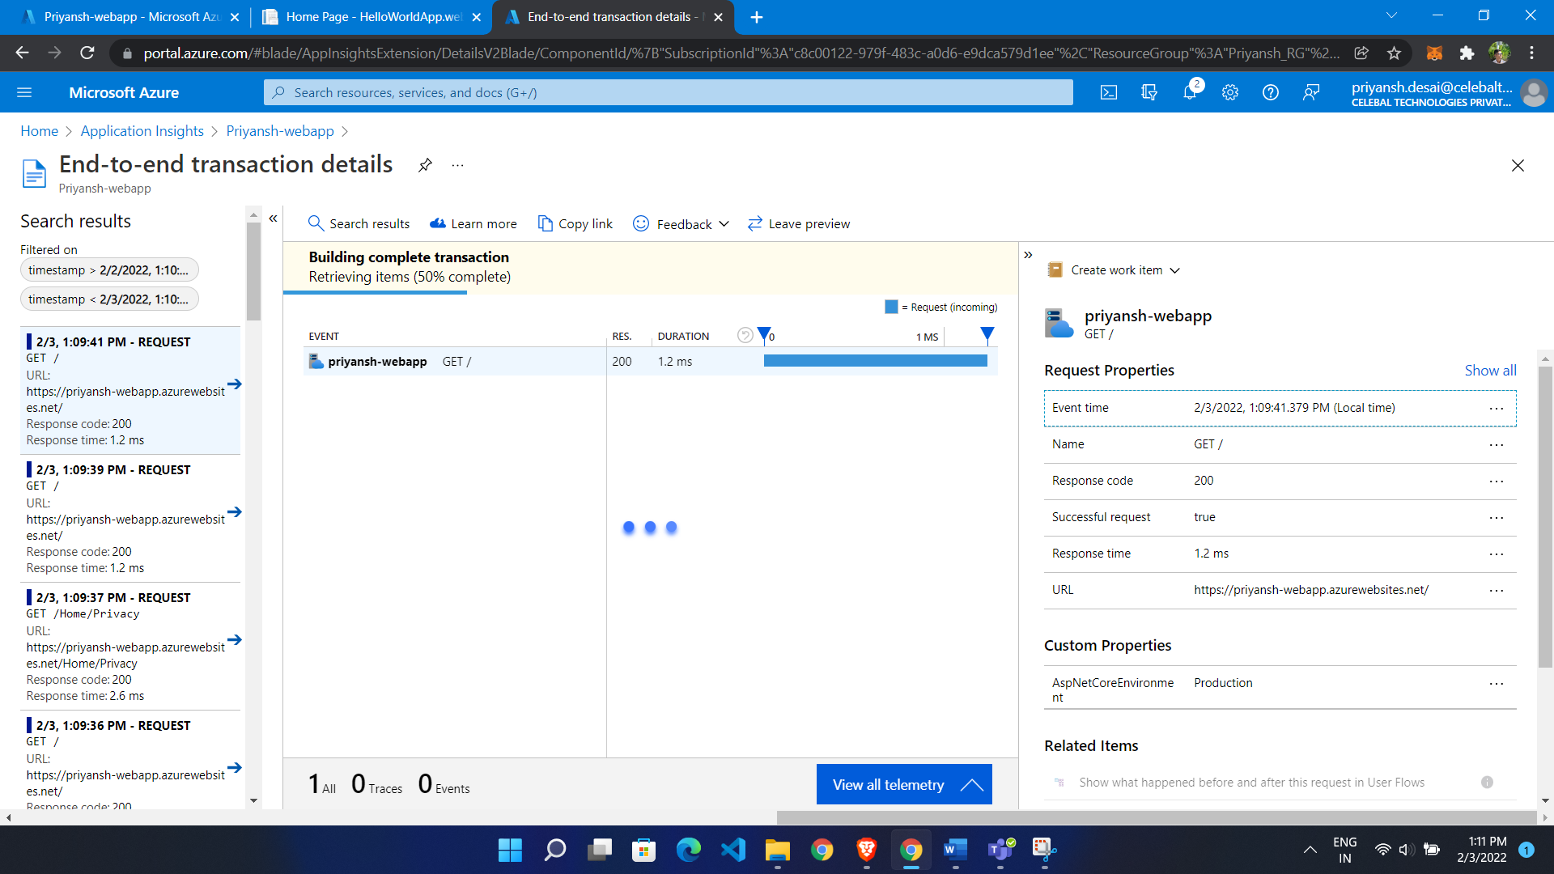

It will shows us event time, response code and all

Availability: if we want to monitor our url like it is accessible or not

* Go to Availability
* Click add classic Test
* Give name
* Select SKU like want to monitor single URL Or multiple URL
* Give URL

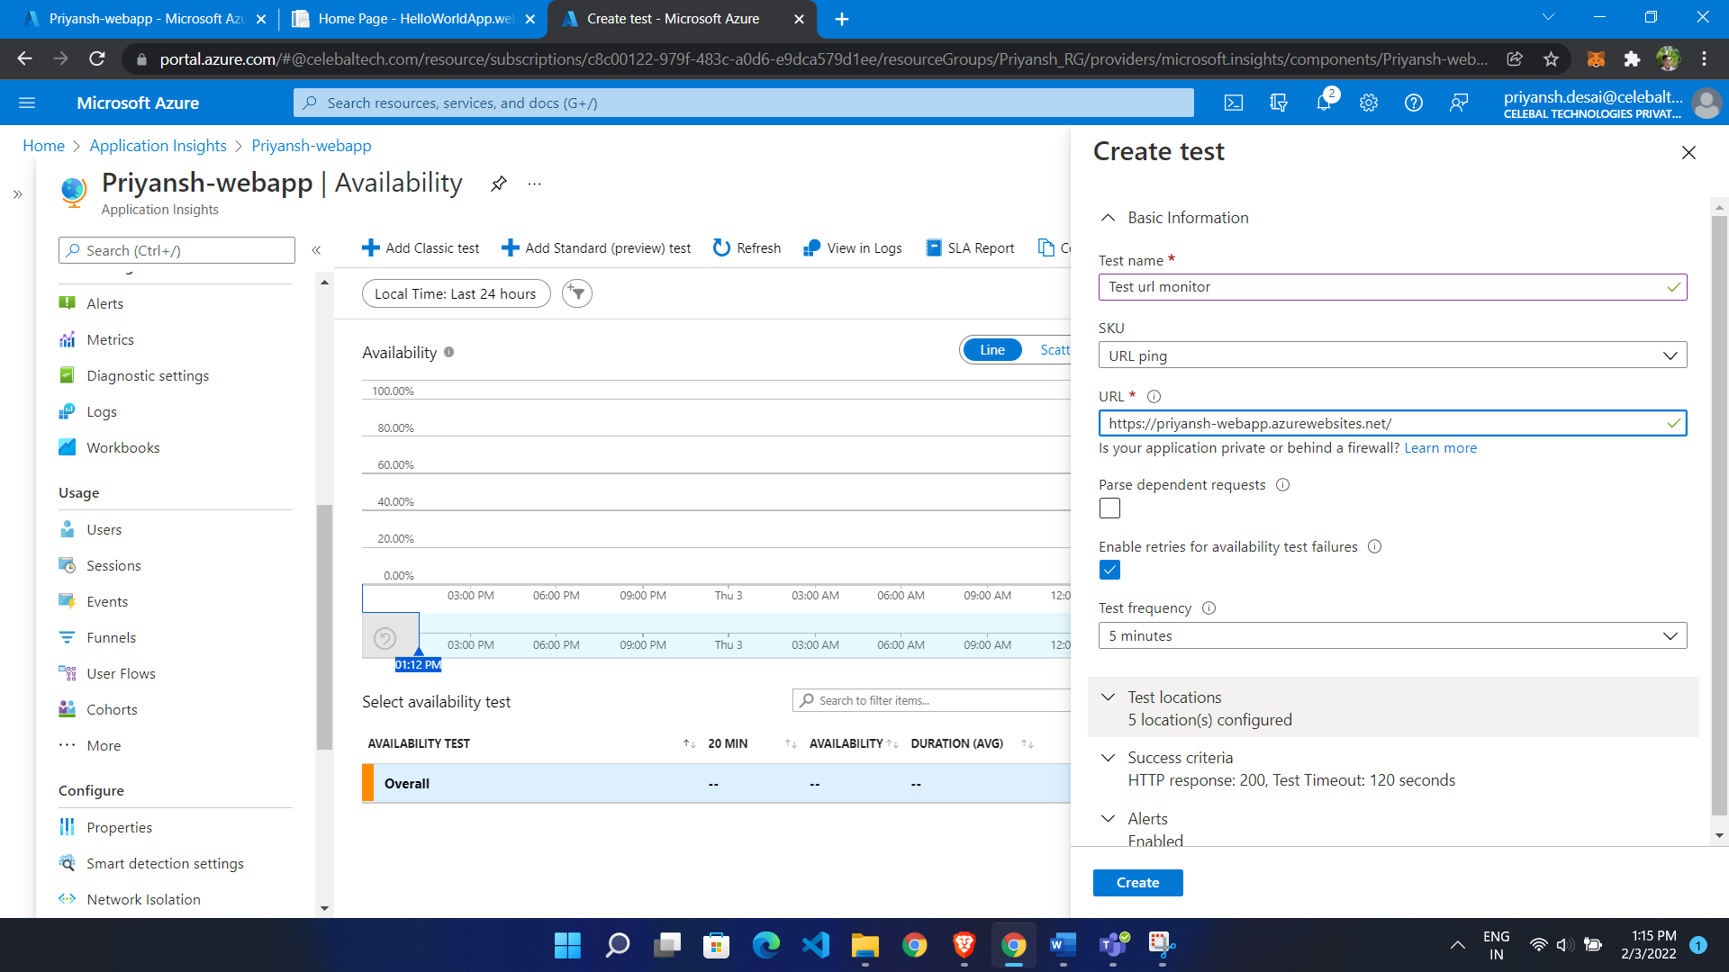

Now it will test availability of particular URL

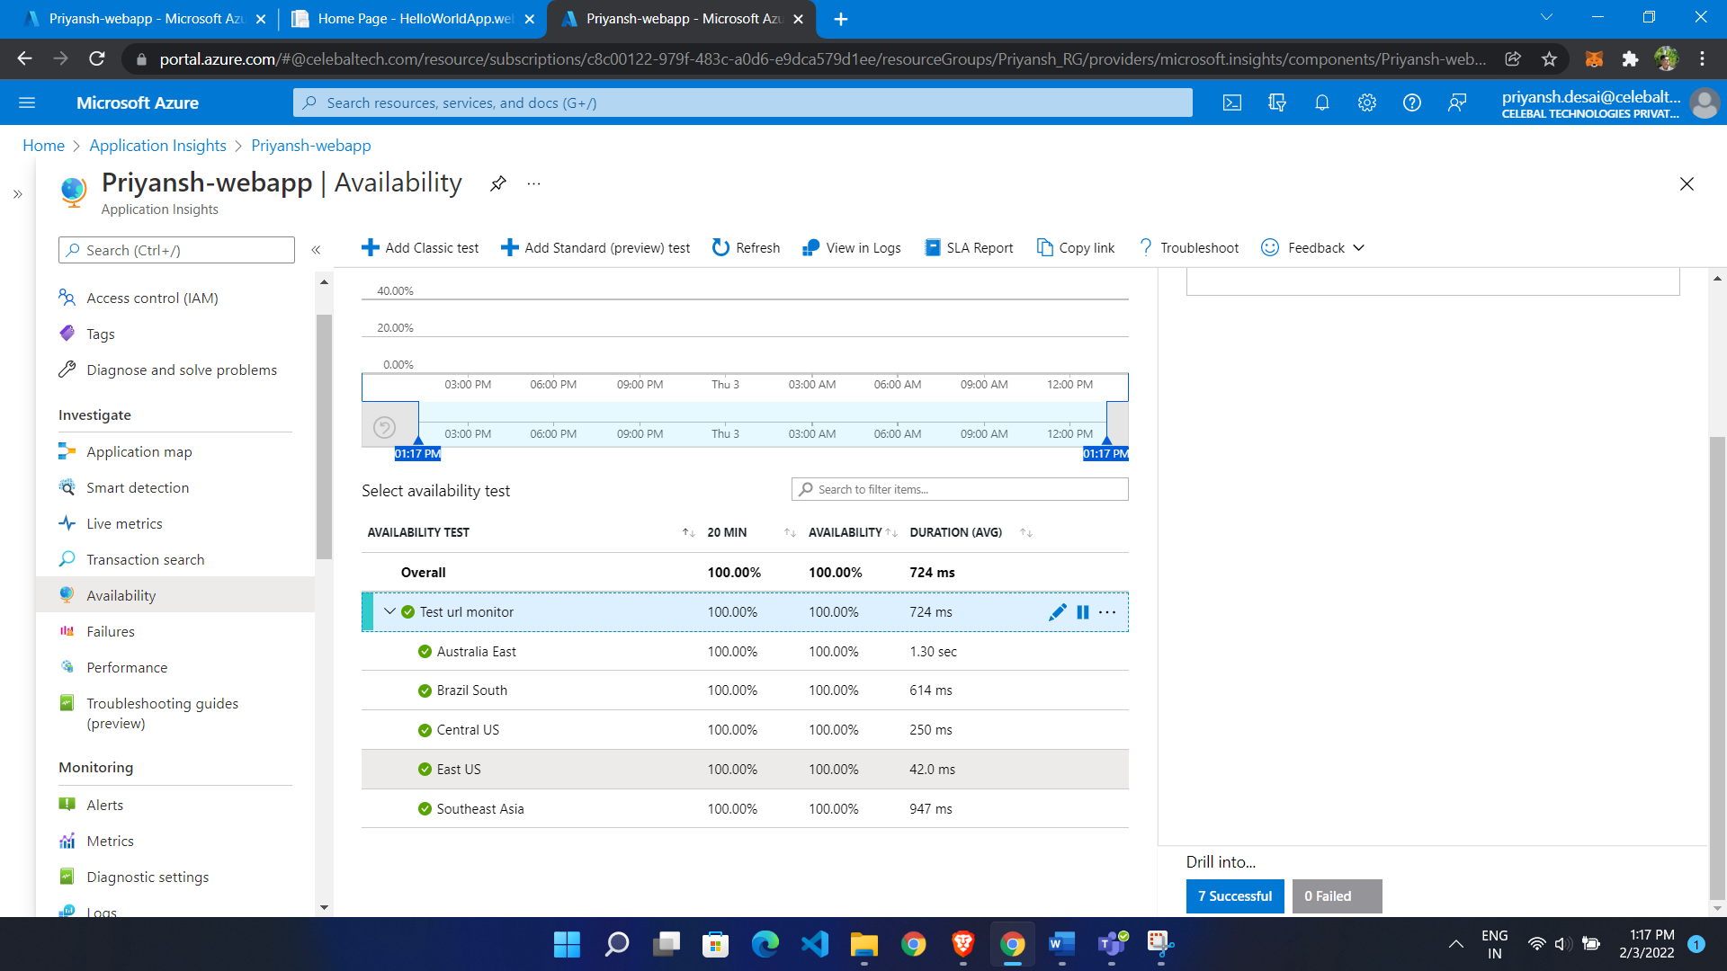

Url is live now and it will check in all region

Now we stop Web app it will check in 5 min because it is by default 5 min

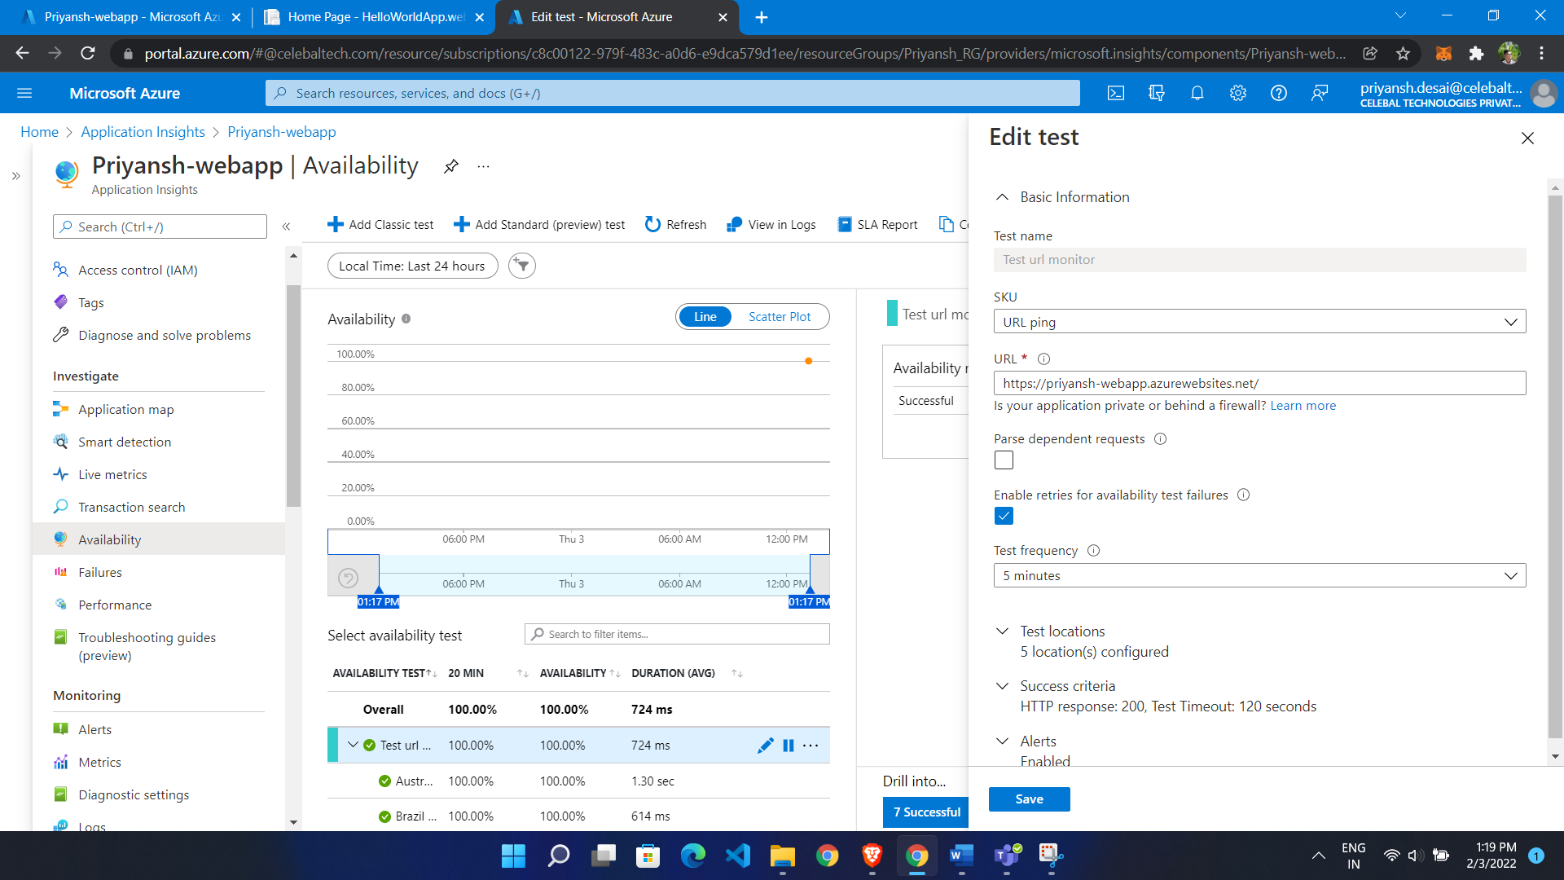

Now it will give us Fail

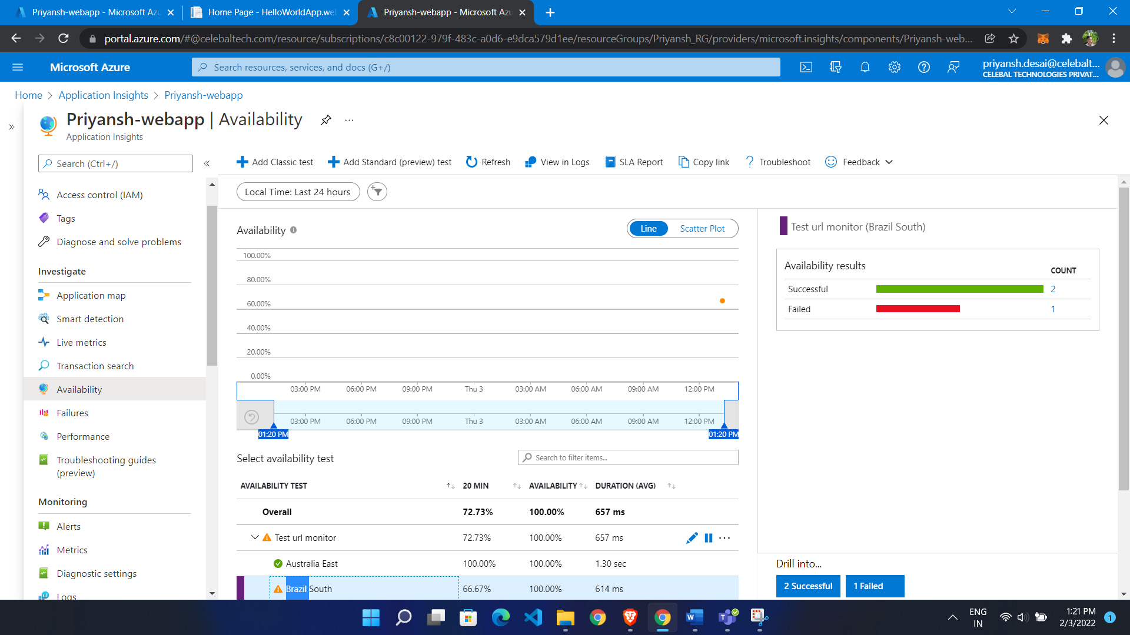

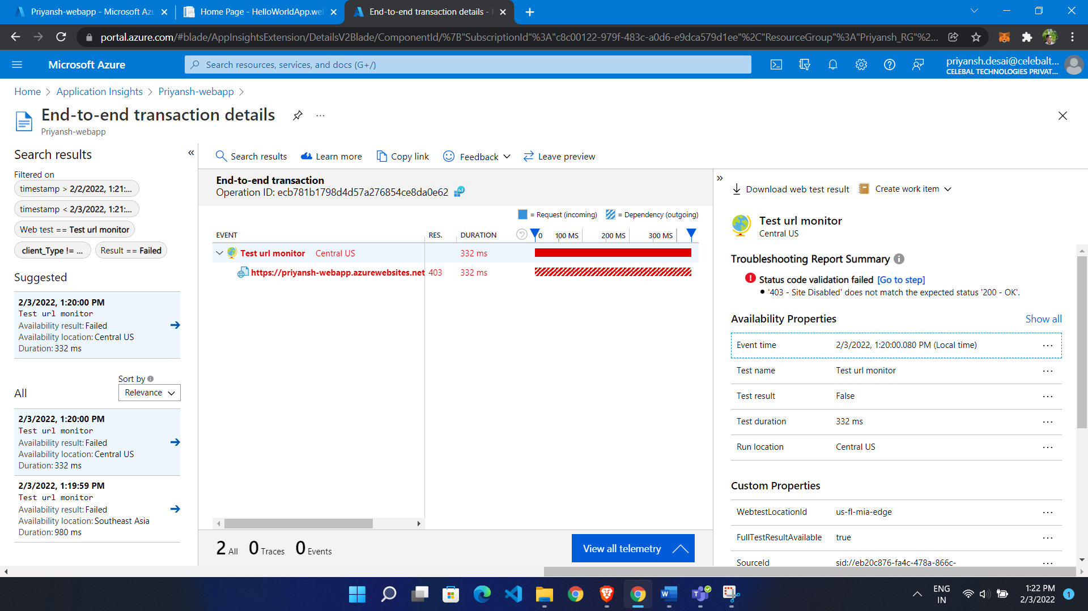

Generate Dashboard:

* Go to application insight
* Click on Application Dashboard

